
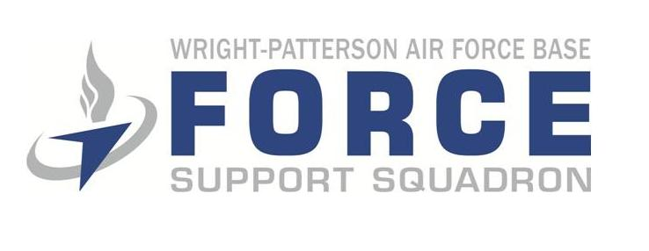

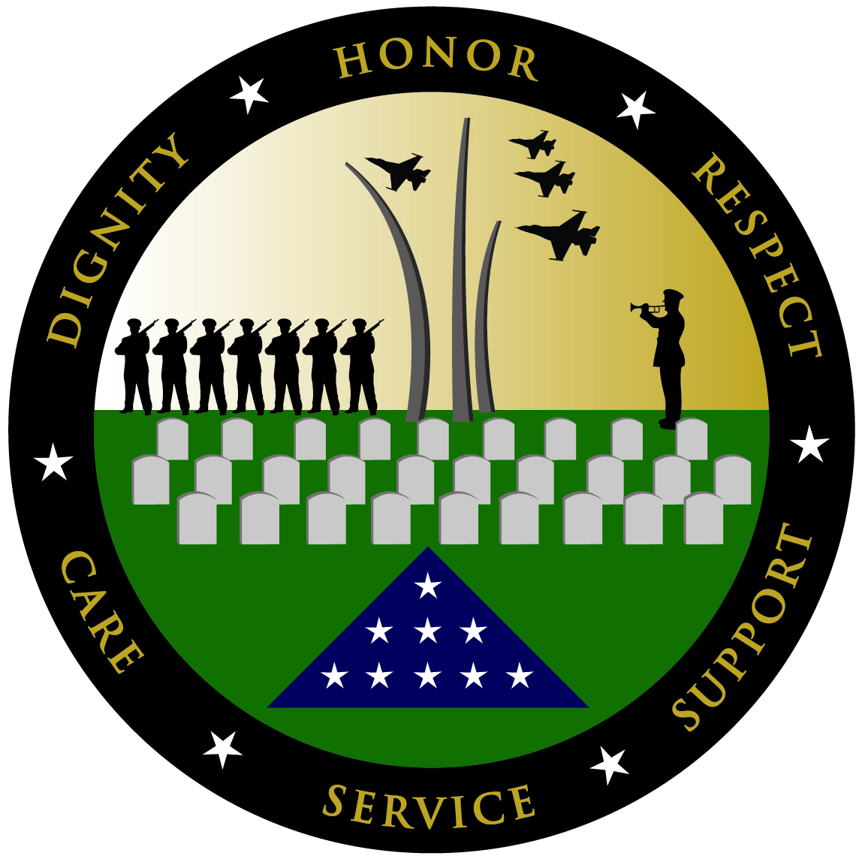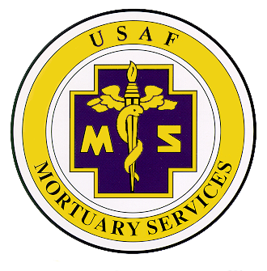
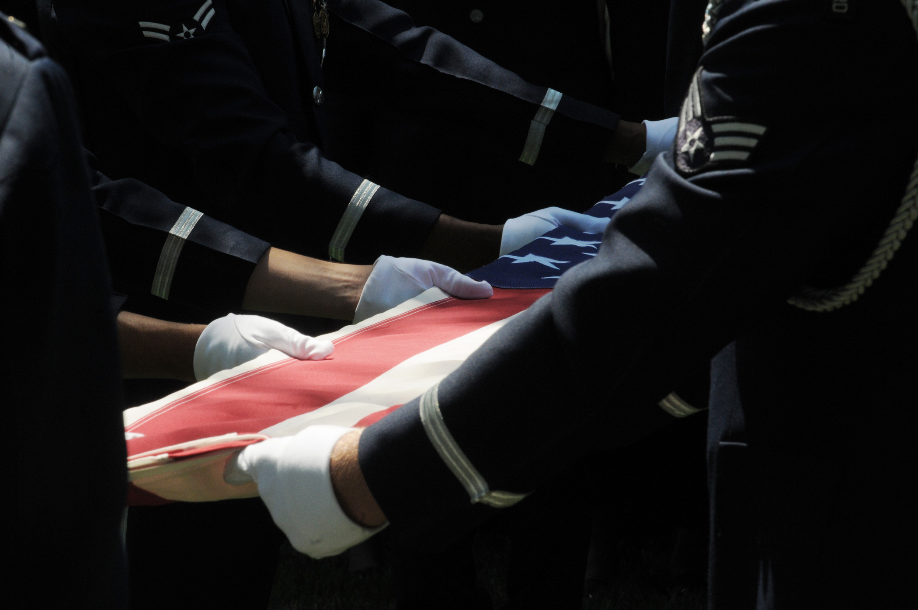

MORTUARY AFFAIRS

INFORMATION GUIDE

FOR COMMANDERS AND FIRST SERGEANTS

 | DEPARTMENT OF THE AIR FORCE  HEADQUARTERS 88TH AIR BASE WING (AFMC)  WRIGHT-PATTERSON AIR FORCE BASE, OHIO

MEMORANDUM FOR UNIT COMMANDERS AND FIRST SERGEANTS

FROM: 88 FSS/FSO

SUBJECT: Mortuary Affairs Information Guide for Commanders and First Sergeants

1. One of the most sensitive and probably the most important job within the 88th Force Support Squadron is that of Mortuary Affairs. There are many complex aspects of Mortuary Affairs operations and, if they are not professionally managed, it can greatly embarrass the Air Force and cause unnecessary anxiety to the next of kin. This guide is designed to define your role during a mortuary case in your unit.

2. The information in this guide is concise for easy reading and formatted for quick reference. It is general in nature and may apply a bit differently in each case. It is meant to give you a general overview, not to make you an expert. I encourage you to review the information and keep it handy for reference. Please feel free to contact myself at 937-257-7190 / 937-503-6084 or Stefanie Mullinix at 937-257-7574 / 937-308-9828 if you have any questions or concerns.

SARAH J. BURKHART, NH-03, DAF
Operations Officer

Attachment:
1. Quick Reference POCs
2. Key Players
3. Death in Your Squadron
4. Active Duty Entitlements
5. Frequents Problems
6. Sample Statement of Good Standing
7. Checklist

1

QUICK REFERENCE POINT OF CONTACT

WPAFB LISTINGS:

WPAFB Mortuary Officer (Sarah J. Burkhart) 257-7190, C- (937) 503-6084

WPAFB Mortuary Technician (Stefanie R. Mullinix) 257-7574, C- (937) 308-9828

Casualty Affairs 257-6405

Chaplains Office 257-7427

HQ A1S Mortuary Affairs 257-2830

Base Operator 257-1110

Command Post 257-6314

Security Forces 257-6516

Airman Readiness Center 257-3592

Base Honor Guard 257-8964

Public Affairs 257-6306

Legal Assistance 257-6142

Mental Health Care (TSR) 257-6877

OUTSIDE AGENCIES:

Headquarters, Air Force Mortuary Affairs 1-800-531-5803

Regional Veterans Administration 1-800-827-1000

Air Force Casualty 1-800-433-0048

Dover Port Mortuary 1-800-565-1398

USAF Survivor Assistance 1-800-872-3435

Local Police 911

2
KEY PLAYERS

1. Air Force Mortuary Affairs Operations Center (AFMAOC): Exercises staff surveillance and operational control over all phases of the worldwide program and develops procedures, techniques, and mortuary processes for operations. Provides technical and specialized assistance at installation or major command’s (MAJCOM) request for search and recovery (S&R), identification of remains, preparation and disposition of remains, and any other mortuary affairs related concern. Briefs the Person Authorized to Direct Disposition (PADD) if they live CONUS and the death occurs OCONUS.

2. Mortuary Officer & Alternates: The Mortuary Affairs Officer (MAO) is appointed by the FSS Director, IAW DAFI 34-160, Mortuary Affairs Program. The MAO is the FSS Operations Officer who administers and executes the program for the Installation Commander. All deaths involving active-duty Air Force members will be reported to the MAO by the base command post. The MAO is responsible for the administration and operation of all activities related to the mortuary affairs program. These include: briefing the PADD of mortuary entitlements, search and recovery of remains of personnel from accidents or disasters, benefits related to funeral arrangements including burial or cremation, transportation of remains to the final resting place, disposition of personal property of active duty members, escorts, honors, family member transportation, and paperwork associated with these activities.

3. Casualty Assistance Representative (CAR): The Casualty Assistance Representative (CAR) is designated in accordance with AFI 36-3002, Casualty Services, the single source document for casualty notification and assistance; it may be available to the Next-Of-Kin (NOK). The CAR is responsible for transmitting casualty reports to the Air Force Personnel Center (AFPC), the Defense Finance and Accounting Service (DFAS), and other concerned agencies; briefing Casualty Notification Officers on their duties and responsibilities; and assisting the NOK or other eligible beneficiaries in claiming all government benefits and entitlements. During their family briefings the CAR addresses: Air Force Benefits and Entitlements, Social Security Benefits, Veteran Affairs Benefits, miscellaneous benefits (commercial life insurance, credit union, banks, etc…), and educational assistance. The Air Force Casualty Branch, located at AFPC, is manned 24 hours a day, 7 days a week to assist commanders, CARs, and others who require support in fulfilling the casualty duties and responsibilities.

NOTE: The Mortuary Affairs Programs and Casualty Assistance Programs are two distinct programs under the Force Support Squadron.

4. Person Authorized to Direct Disposition (PADD): The person designated by the active duty member to be entitled to direct disposition of his/her remains.

5. Next Of Kin (NOK): The Next of Kin (NOK) is defined as the closest relative of a deceased person and there is a specific legal order, which determines the NOK. The Air Force is bound by this legal order, regardless of personal feelings or family situations. Federal law determines this legal order.

3

6. Person Eligible to Receive Effects (PERE): The person authorized by law to receive the personal effects of a deceased military member. Receipt of personal effects does not constitute ownership. As with the NOK determination, there is a legal (Federal Law) order for determining this entitlement. The order for receiving property is not necessarily the same as for determining disposition of remains.

NOTE: This entitlement is only to determine who receives the property from the Air Force. Ownership is determined by other civil statutes. The Air Force does not declare ownership.

7. Summary Court Officer (SCO): The SCO is a commissioned officer appointed on orders by the Installation Commander, pursuant to DAFI 34-160, Chap. 13., The SCO process is part of the larger Mortuary Affairs program and is specifically designed to help the PERE through the management procedures necessary to close out a member’s affairs. The MAO will immediately request that the Installation Commander appoint a SCO for all active duty deaths. The selection of a SCO may be from any base organization. The SCO obtains property disposition instructions and the names and addresses of the authorized recipients from the MAO. The SCO should secure, inventory, package, and ship personal property to the authorized recipient. The SCO will also turn in military identification and other military documents and equipment; dispose of mail, personal papers, funds, and negotiable instruments. The SCO should be removed from all other duties and responsibilities until all actions are complete. The SCO has 120 days from the time of appointment to complete his/her duties. The MAO is responsible for training the SCO on their duties.

8. Escorts: Only ONE ESCORT is authorized to accompany the remains to the final destination or to hand carry the cremated remains of a deceased military member who is entitled to full mortuary benefits. The escort accompanies the remains from shipping facility (CONUS) to final destination. In an overseas location, the Aircraft Commander acts as an Official Escort until arrival at the aerial port of debarkation (APOD). The PADD may request, by name, a civilian or military “Special Escort” or request that the MAO appoint an escort. Appointed escorts will be of same rank or higher as the deceased members. All escorts act IAW, AFPAM 34-504, Escorting Deceased Air Force Military Personnel.

NOTE: “Unit Reps”, are not Official Escorts. The unit is responsible for funding all “Unit Reps”. They are not authorized to travel under any mortuary entitlements.

9. Family Assistance Representative (FAR): The FAR can be assigned to any NOK. However, a NOK can decline their assistance or support. The FAR is selected by the decedent’s Unit Commander and is provided initial training by the WPAFB FSS. They are expected to make contact with the families to which they are assigned at least daily until the funeral is over or the family wishes otherwise. They will help families conduct benefits-related business with other Air Force personnel (casualty affairs, mortuary affairs, etc…) and to work with other supporting military personnel as needed. The FAR’s role is to help facilitate communications between the family and subject matter experts and investigators. They will not attempt to perform the duties of other functions or subject matter experts described above but will simply relay questions or concerns to the appropriate personnel. FARs may be Officers or Senior Noncommissioned Officers (E-7 or higher). The FAR must receive training from MAO and act IAW, AFI 34-1101, Assistance to Survivors of Persons Killed In Air Force Aviation Mishaps and Other Incidents.

4

IF AN ACTIVE DUTY DEATH OCCURS IN YOUR SQUADRON

1. Notification: When an active-duty member or dependent death occurs, someone on base is notified----the SFS, hospital, MAO, command post, casualty representative, group, wing, or squadron commander. If you are contacted by anyone about a death, call the command post on base. The command post will make all other notifications.

a. Active Duty Deaths: The on-call casualty assistance representative will be contacted by the command post to ensure the PADD and NOK are officially notified of the death. Notification is made by a notification officer, a chaplain, and if determined appropriate a medical representative. If NOK lives in the area, the squadron commander will make notification. If NOK is outside of area, the responsibility is carried out with the cooperation of other commanders and HQ AFPC/DPWCS.

b. Dependents of Active Duty Personnel: The unit commander accompanied by the appropriate staff members (i.e., first sergeant, chaplain, medical, etc.) makes the notification. If the next of kin has already been notified, a visit to the family is still appropriate.

2. Notification to Mortuary Officer: The MAO should be notified of the death by the command post or the appropriate local authority off base. Once notification has been made to the PADD, a call to the mortuary officer should be made to advise that the PADD has been notified. The mortuary officer will then place a call to the PADD advising them of who he/she is and why they are calling At that time he/she will determine a date/time to for PADD brief.

3. Explanation of Mortuary Benefits: Once positive identification has been established, the MAO will arrange an official mortuary briefing with the PADD. If a search and recovery operation is ongoing, the MAO will need to stay in contact daily with PADD to brief on search and recovery operations. Once the briefing is completed, the MAO can proceed with disposition (i.e., funeral homes, cemetery, transportation, escorts, etc.).

4. Recovery of Remains: This can be accomplished several different ways depending on circumstances of death and where the death occurred. If death occurred off-base, remains are probably under the jurisdiction of the local county coroner or medical examiner. The remains could be at a local mortuary, hospital, or morgue. If on base, the local county coroner or medical examiner could still have jurisdiction. Either way, it will be the mortuary officer’s responsibility to locate the remains and procure the release of the remains.

5. Secure Personal Property: The mortuary officer, working with the unit commander, Security Forces will need to ensure the member’s personal property is safeguarded and secure. This could include offices, workspaces, vehicles, or quarters on base.

6. Summary Courts Officer (SCO): Active duty deaths only. The installation commander will appoint a SCO. The mortuary officer will brief the SCO on their duties and responsibilities. The SCO should not serve as the remains escort as no SCO actions can take place while SCO is escorting remains to destination.
5
7. Transportation of Remains/Escort: The MAO in conjunction with the funeral home will handle all arrangements for shipment of remains as well as travel for the escort.

NOTE: MILAIR is not authorized in CONUS, including Alaska and Hawaii.

8. Escort: A member of equal or greater rank will be appointed by the unit commander to act as an escort. The escort will be placed on orders and accompany the deceased member to the receiving funeral home. Escorts can also be personally chosen by the family. The escort will be briefed by the MO on his/her duties and provide the travel orders for the escort.

9. Honors: Military honors are authorized for active duty personnel, retirees, and veterans. The MAO will work with the honor guard from the installation closest to the final destination to perform honors.

10. Entitlements for Mortuary Services: The MAO will handle all entitlements dealing with expenses associated with funeral services unless the NOK elects otherwise. The MAO will work directly with the PADD and funeral home to ensure they are comfortable with their decisions. Direction will be in the form of written, signed documents.

11. Personal Property: The MAO will work with the SCO and TMO to make sure all personal property is shipped to the authorized recipient.

NOTE: The best help you can give the PADD and NOK during this tragic time is to console him/her and offer to assist in any way you can. However, any questions regarding the death, remains, search and recovery, arrangement of funeral services and entitlements should be forwarded to the WPAFB Mortuary Officer. Blunt and inflexible as this statement is, most confusion, irritation, and dissatisfaction in how the Air Force assists the PADD and/or NOK occurs at this stage as a result of untrained personnel with the best of intentions providing incorrect or inappropriate information. Call the Mortuary Officer regularly to receive an update on actions.

6

ACTIVE DUTY ENTITLEMENTS

1. Mortuary Entitlements: The Air Force will provide the following services for members who die on active duty:

A. Preparation of Remains.

B. Clothing:
- Service Dress Uniform
- Flight Suit
- Civilian Clothing

C. Casket:
- 18 Gauge Metal Sealer (Silver)
- Solid Hardwood

D. Urn (if cremation desired):
- Solid Bronze
- Hardwood

E. Transportation:
- Commercial Air
- Hearse

F. Escort: (Only one escort Authorized)
- Appointed
- Special (Family requested)

G. Travel to Attend Funeral Services:
- Spouse
- Children & Step Children
- Parents &Step Parents
- Siblings & Step Siblings
- In Laws & Step In-laws
- Or, if none above, the PADD and two others

H. Full Military Honors:
- OIC or NCOIC
- Pallbearers
- Firing Party
- Bugler
- Color Guard
- Chaplain, (If NOK Desires)
- Flyover (If Authorized)

I. Flag(s) & Hardwood Flag Case(s):
- Spouse
- Each Child
- Parents (1 if married, 2 if divorced)
- PADD (If none above options are named)

J. Headstone & National Cemetery Space:
- Provided by Veterans Administration

K. Summary Court Officer

L. Family Assistance Representative

NOTE: The Mortuary Officer is responsible for briefing the above entitlements.

7

CHECKLIST

Unit Commander Actions upon notification of active duty death:

- Immediately contact WPAFB Mortuary Office or the Command Post; Sarah J. Burkhart (Mortuary Officer) 257-7190 or (937) 503-6084; Stefanie Mullinix (Mortuary Technician) 257-7574 or (937) 308-9828; Command Post 257-6314.

- Locate and secure personal property and effects (worksite/residence) under Government control until a Summary Courts Officer (SCO) is appointed.

- Identify a commissioned officer to act as Summary Courts Officer (SCO) who will be placed on official orders by the Installation Commander. (See page 4).

- Identify a Family Assistance Representative (FAR) to be placed on official orders by the Installation Commander within 24 hours of death notification. (See page 4).

- Assist in identifying an Escort to be placed on official orders to accompany the remains from the shipping facility to final destination when the two places are not located in the same area. The escort must be of equivalent rank to the deceased or higher. (See page 4).

- Prepare Commander’s Letter of Condolence to NOK.

- Prepare a Letter of Good Standing, if requested.

- Determine if on-base memorial services will be held for your unit (NOT a requirement) if desired please contact the Mortuary Office at one of the numbers listed above.

8

IF A CIVILAIN DEATH OCCURS IN YOUR SQUADRON

Civilian deaths are not typically handled by the Mortuary Affairs Office. The only time mortuary funds are distributed for civilian deaths is when the member is on official TDY status. If a civilian passes away while TDY, the mortuary office will fund for the preparation of remains transportation of remains from the location of the TDY back to their home of record.

Unit Commanders or First Sergeants need to contact the Command Post (257-6314), Civilian Personal (POC Shawnetta White: 904-3272) and Casualty Affairs (257-6405) to report all civilian deaths. If the civilian passes away on-base during working hours immediately contact the appropriate emergency response authorities (base paramedics, security forces, OSI) before contacting the Command Post, Civilian Personal, and Casualty Affairs.

If a civilian death occurs while the member is not on base, Unit Commanders should contact the Command Post, Civilian Personal (POC Shawnetta White: 904-3272) and Casualty Affairs as soon as they are notified. The Mortuary Affairs Office (Jodie L. Spires or Stefanie Mullinix) should also be contacted on every civilian death even the ones not eligible for mortuary entitlements. Outside of these agencies no one should be informed about the death until the family has been officially notified.

Checklist for civilian deaths:

- Have you accomplished the above notifications?

- Conduct a search of the employee’s work area to secure all personal possessions, itemize, arrange for pick up, and obtain the proper signatures.

- Arrange for turn-in of government property charged to employee (keys, GPC, ID, etc.)

- Prepare a letter of condolence for the family

- Are you planning on having a memorial service for the decedent’s unit? (Not required)

9

FREQUENT PROBLEMS/COMMON ISSUES

1. Extending entitlements or making promises to NOK that are not authorized or can’t be kept:

A. Transportation of Remains: Transportation of remains in CONUS, including Alaska and Hawaii is authorized using a commercial carrier or hearse. MILAIR IS NOT AUTHORIZED. The WPAFB Mortuary Officer will brief the family and arrange transportation of remains.

B. Travel to Attend Funeral Service: The spouse, children, siblings, and parents are authorized to travel to the funeral service. Consult your mortuary officer if the family dynamics are beyond the scope of this guidance. The WPAFB Mortuary Officer will brief the family and arrange these services.

NOTE: This does not include travel of family members to attend a base memorial service.

C. Escorts: ONLY ONE ESCORT IS AUTHORIZED. The family can request a special escort or an escort will be appointed by the MAO. Any “UNIT REP” that a squadron promises will be funded by the squadron and will have no official duties for mortuary purposes. The MAO at the shipping installation will brief the family and make all arrangements for the escort. For overseas deaths, the commander of the military aircraft will act as the escort to the APOD. Once the remains arrive at the APOD, an escort will be appointed or if requested by the NOK, the special escort will perform their duties.

D. Flags & Hardwood Flag Cases: Flags and Hardwood Flag Cases are authorized as follows: One to spouse, one to the parents if married or one each if divorced, and one for each child. If there is no one listed above then the flag would be authorized to go to the person directing disposition of the remains. These flags are not authorized to be used at the base memorial service.

2. Providing incorrect status to NOK:

Questions related to search and recovery, identification and view ability of remains should be directed to the WPAFB MAO. Exception: Overseas case inquiries should be directed to the AFMAO Center toll free number for use in CONUS.

3. Not directing NOK inquiries to the mortuary officer or casualty assistance representative

A. The casualty assistance representative will brief the family on the following benefits: Death Gratuity, Servicemen’s Group Life Insurance, Unpaid Pay and Allowances, Dependent Indemnity Compensation, Survivor Benefits Program, Social Security, ID Cards, Medical and Dental Benefits, Educational Entitlements, Future use of Base Exchange and Commissary, and DD Form-1300 (Report of Casualty).

B. The Mortuary Affairs Officer will brief the family on the following: Funeral and Burial Entitlements, Memorial Service Arrangements, Military Honors, Headstone and Memorial Marker Program, Search and Recovery Operations, Identification, view ability of Remains and Body-Not-Recoverable (BNR) entitlements.

10

Place this memo on the unit letterhead

DATE:

MEMORANDUM FOR: (NAME AND ADDRESS OF THE NATIONAL CEMETARY)

FROM: (DECEASED MEMBERS SQUADRON COMMANDER)

SUBJECT: STATEMENT OF GOOD STANDING

- This letter is to inform you that Staff Sergeant John J. Doe, SSN# 000-00-0000, was a (Flight Engineer) in good standing, assigned here with (MAJOR COMMAND), (WING), (SQUADRON), (BASE) at the time of HIS/HER death, (DATE).

- There were no pending actions against HIM/HER. HIS/HER service was honorable.

(SQUADRON CC NAME), Colonel, USAF
(NAME OF SQUADRON)
Commander

11

